**ReachMe**



**Problem Statement :**

In daily life, one person uses on an average 4 different social media apps. The user keeps scrolling and switching between the different apps which creates distraction and affects productivity.



**Solution :**

From an individual point of view, people use social media for sharing their memories, and information. Moreover, it is also used for content writing, video uploading, and image uploading online. Everyone has their own preferences and needs when it comes to social media apps choices.

Our solution to this problem statement is to create a ***social media web app*** that contains all the favourites and popular features of Instagram, Facebook, WhatsApp, Twitter, and Snapchat. Our web app will provide everything in place which will match the user's social media goals.

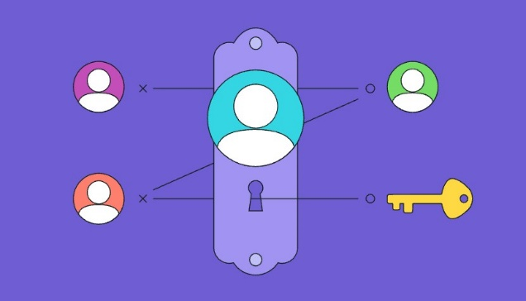



**Features of App:**

* Simple and Friendly User Interface (UI)
* Visually Appealing and Accessible Design
* Secure Login
* Networking Element
* Content Sharing Method
* Messaging System
* Open Forum
* Real-Time Notifications
* Customizable Privacy Settings
* Versatility and Responsiveness



**Technology Stack :**

* MongoDB
* ExpressJS
* ReactJS
* NodeJS